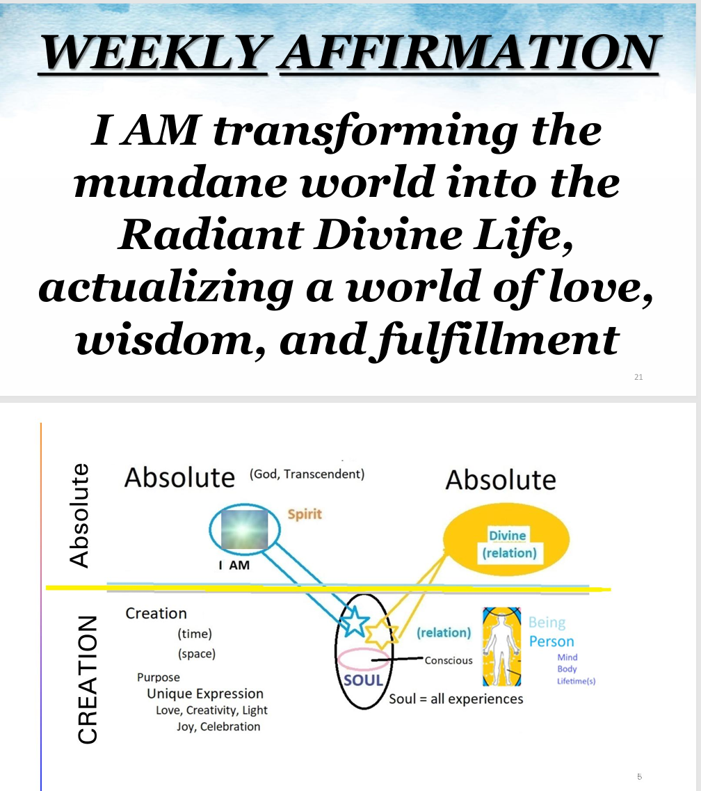

REVISION4 WEEKLY AFFIRMATION
I AM transforming the mundane world into the Radiant Divine Life, actualizing a world of love, wisdom, and fulfillment
diagram
The top half represents the Absolute, Transcendent Reality behind this universe and the source of everything in the universe. Unity teachings call that God.
In this Eternal Being is the Divine Spark (our Spirit) one with the Divine.
Because the nature of that Absolute is LOVE, and the nature of Love is to flow the Divine creates the universe to allow the expression of love and the divine attributes (creativity, compassion etc).
The LOWER half represents the Divine Creation.
The divine spark is given a Soul (a spiritual body) to enter the universe. The soul holds all of our experiences, values, consciousness.
THE SOUL IS AN EXPRESSION OF OUR DIVINE RELATIONSHIP and is a result of the consent of the Divine Spark ….
THE HIGHER SELF knows the DIVINE RELATIONSHIP and our purpose.
Soul takes on causal, astral and physical bodies.
The SOUL is our unique expression of the Divine shining through this person that we are now. Our purpose is to bring the Divine attributes into expression. “You are the light of the world”
[[[[[prayer]]]]
Songs [IN DREAMS]

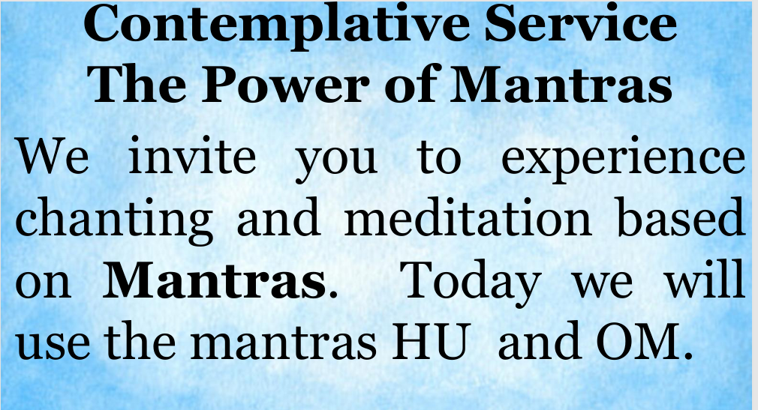
THIS AFFIRMATION expresses two aspects of our Being 1. WHAT I AM --- DIVINE SPARK never changing / eternal
2. WHO I CHOOSE TO BE in this creation ((((I choose to manifest (actualize) the DIVINE attributes ))))
So, please repeat with me:

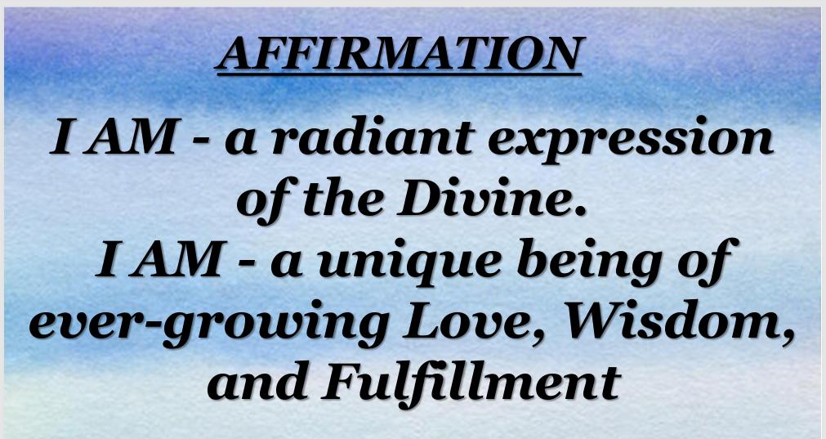
AND THE DEGREE OF THAT FULFILLMENT is the amount of JOY that we experience in life.

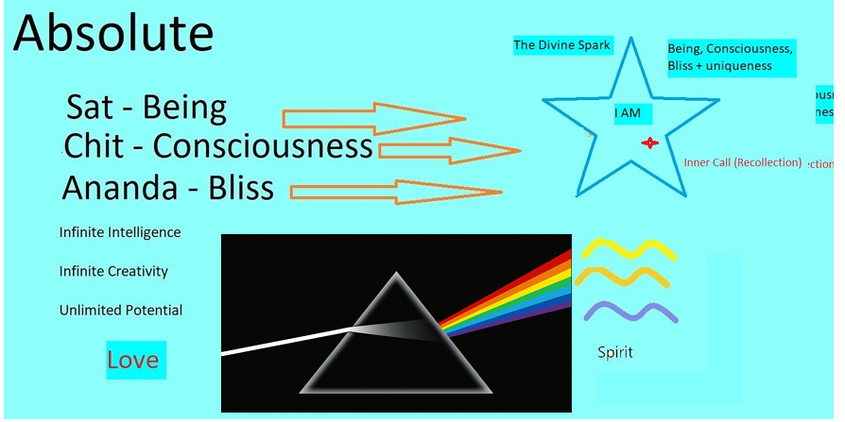

GOD IS SAT CHIT ANANDA (BEING , CONSCIOUSNESS and BLISS) and we
THE DIVINE SPARK WITHIN US IS EXACTLY that Divine Nature .. BEING CONSCIOUSNESS BLISS with the gift of UNIQUENESS

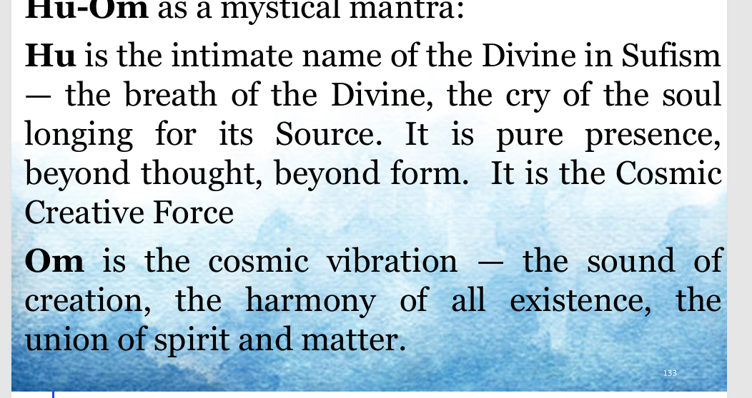

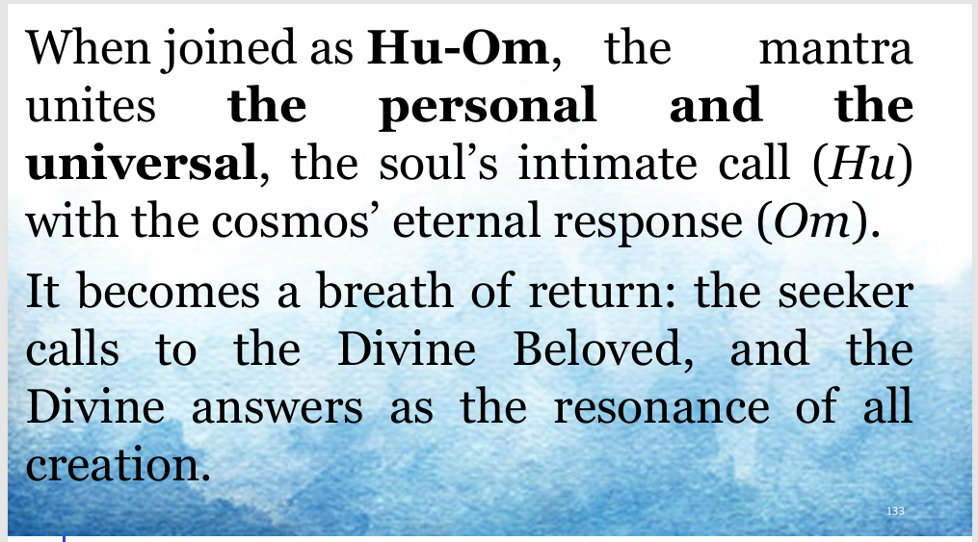

SO I INVITE YOU TO CHANT with us

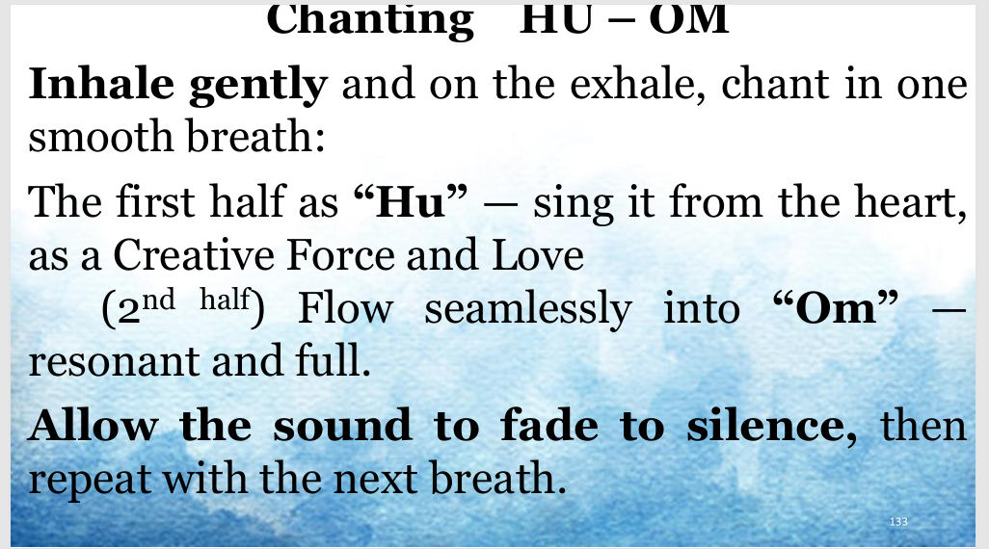

SING any note with our band and repeat the mantra at your own rate of breath (C Mixolydian Bb)
We’ll do this for 5 minutes
WHEN THE CHANTING ENDS, we will go directly into an extended meditation .. you may continue to silently repeat this mantra or whatever you practice

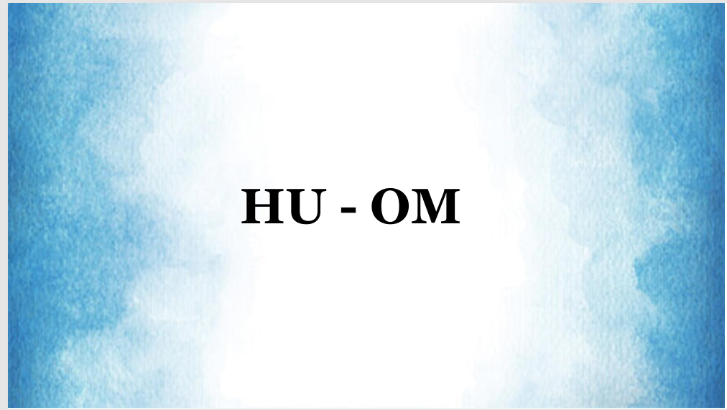

CHANTING 5 Minutes
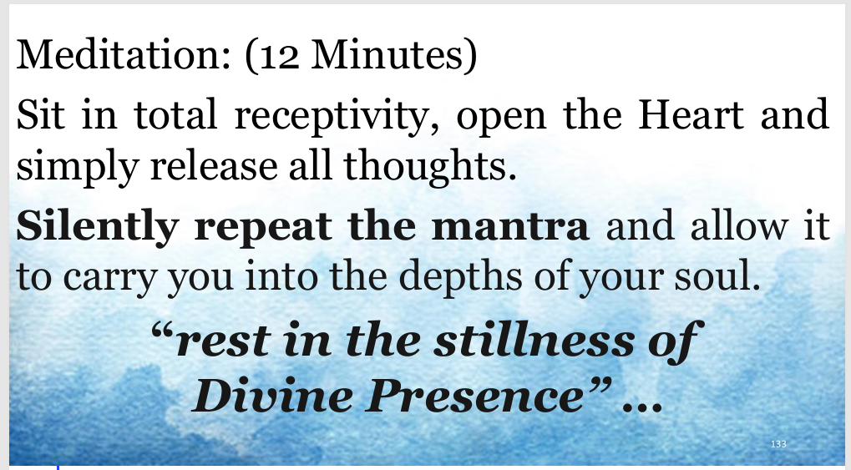

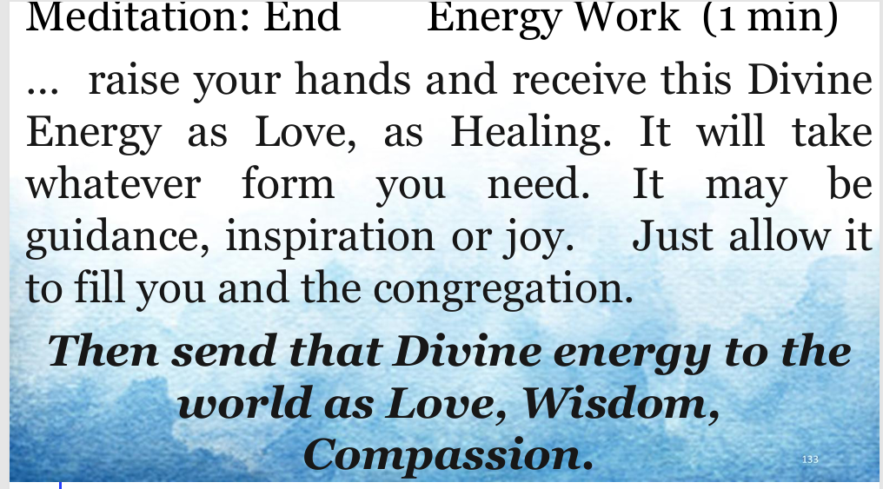

WE DO THIS FOR THE GOOD OF ALL BEINGS .. in the name of the DIVINE WHICH IS LOVE
What we have done today reflects our AFFIRMATION
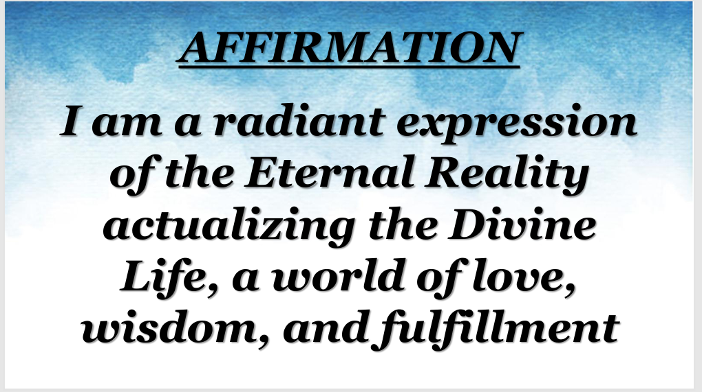

AWAKENING song

